Jacob Ciurca

Dr. Lu

Lab 9

Cosc 320

11/18/2020

**PreLab:** reviewed what we learned about graphs and reviwed the given header file d_graph.h

**Lab:**

**graphA.dat:**

6

A B C D E F

8

A B 1

B C 1

C A 1

A D 1

C F 1

F C 1

D E 1

E A 1

**Lab09.cpp:**

#include <iostream>

#include "d_graph.h"

#include "d_util.h"

#include <fstream>

using namespace std;

int main()

{

graph<string> g;

ifstream data;

data.open("graphA.dat");

int vertex;

int edge;

string a;

string e1;

string e2;

int e3;

data >> vertex;

for(int i=0; i<vertex; i++){

data >> a;

g.insertVertex(a);

}

data >> edge;

for(int i=0; i<edge; i++){

data >> e1;

data >> e2;

data >> e3;

g.insertEdge(e1, e2, e3);

}

cout << "Here is your starting graph" << endl;

cout << g;

cout << "Inserting edge from F to D with weight 1" << endl;

g.insertEdge("F", "D", 1);

cout << "Erasing vertex B" << endl;

g.eraseVertex("B");

cout << "Erasing edge from A to D" << endl;

g.eraseEdge("A", "D");

cout << "Please enter a new vertex to be inserted" << endl;

string v;

cin >> v;

g.insertVertex(v);

cout << "Here are the neighbors of vertex " << v << endl;

set<string> v5 = g.getNeighbors(v);

int size = 0;

for(auto it = v5.begin(); it != v5.end(); ++it){

cout << *it << endl;

size++;

}

if(size == 0){

cout << v << " has no neighbors" << endl;

}

cout << "Creating vertex G" << endl;

g.insertVertex("G");

cout << "Adding edge from G to C with weight 1" << endl;

g.insertEdge("G", "C", 1);

cout << "Adding edge from G to F with weight 1" << endl;

g.insertEdge("G", "F", 1);

cout << "Adding edge from D to G with weight 1" << endl;

g.insertEdge("D", "G", 1);

cout << "Final graph" << endl;

cout << g;

return 0;

}

**Sample Outputs:**

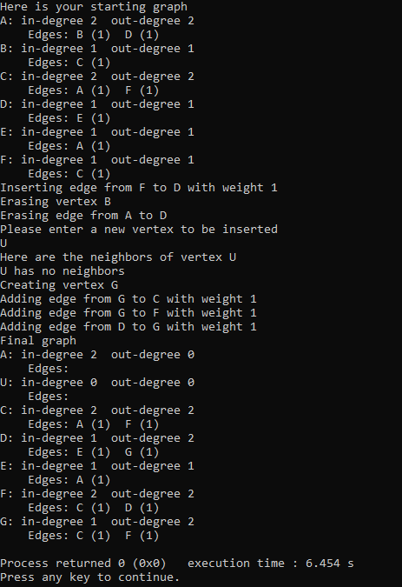

**Post Lab:** This lab was good at giving us practice with implementing and performing operations on a graph. This lab took me around 1 hour 15 minutes to complete and I completed this lab by myself with no help.